Holy Hounds of Hadleigh

Fun Dog Show

2pm Sunday 11 July 2021 in the Deanery Gardens

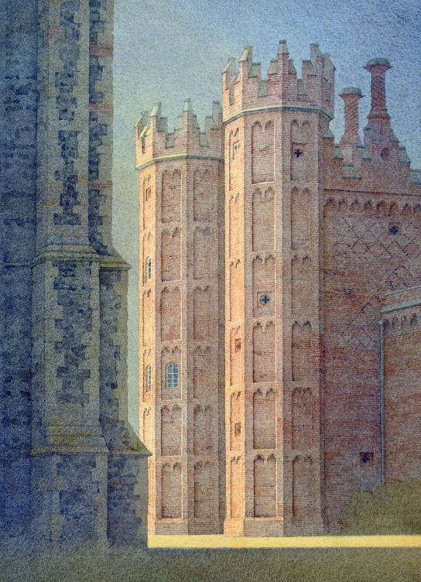
£10 admission per family of humans + canines
Includes entry into up to 5 dog classes:

Young & Veteran Handlers (dog performs a trick!)
Cheekiest, Looks-like-its-owner, Waggiest Tail
Best Dressed in-a-Dog-Collar and many more…

Prizes. Rosettes. Cup awarded for Best in Show

Refreshments including cream teas in the Church

Image by Gerard Stamp

Fundraiser St Mary’s/Deanery Tower, organized by Hadleigh Old School

